EMS for Children Survey Response Rate Plan for EMSC Performance Measures 02 & 03

Option 2 –
- Program Manager emails survey invitation and reminders
- Program Manager leads follow-up calls to non-respondents
- EDC supports manager

Introduction
Any successful survey deployment begins with a well thought out response rate plan. The purpose of this plan is to:
- Help you understand how the survey will be deployed
- Help you understand the tasks that you as the EMSC Program Manager will conduct and how the EDC will support you
- Give you a suggested timeline for these tasks
- Provide you with an overall road map to ensure that together we’ve done all we can to obtain the best possible survey response.

While this plan contains valuable information, it is necessary and helpful for you to have frequent communication with your EDC TA liaison throughout the survey preparation and execution process. Planning with your EDC TA liaison will help to ensure mutual understanding of all steps, answer any additional questions, and brainstorm solutions to problems that may arise.

- reviewing and updating the contact list management system (clms)
As EMSC Program Manager, we are asking you to carefully review and update the “undeliverable” email addresses directly in the Contact List Management System (CLMS) to ensure all potential respondents can be contacted. The EDC may be able to provide you a list containing those agencies that have an undeliverable email address. Updating these could include fixing only the email address or both the email address and contact person.

The information in the CLMS drives effective administration of the survey, including:
- ensuring correct listing of each EMS agency’s name on the website (emscsurveys.org)
- ensuring that the survey invitation and reminders are emailed to the correct individual at each EMS agency for completion
- tracking survey responses by agency
- displaying current response rate reports in Tableau dashboards

If you choose, you may also update or verify other data in CLMS as you deem best.

The 4 most important fields to review and update in CLMS for effective survey deployment are:
- EMS Agency Name
- EMS Agency County
- Contact Name
- Contact Email

You may copy and paste information from another source into CLMS to avoid typing in the information and risking an error. However, if changes are made, please be certain that “EMS Agency Name” and “Contact Name” are always listed in Proper Case, and not in ALL CAPS or all lowercase. Proper Case ensures that correspondence is professional looking.

Updating the contact information in CLMS is the single most critical task for EMSC Program Managers, so please make every effort to get this done! And please understand that you cannot send an updated list of EMS agency information to the EDC to input or upload. All updating of information must be done by the EMSC Program Manager directly in CLMS. Your EDC TA may be able to send you a list of agencies with undeliverable email addresses to help you complete this task.

For your convenience, here are some additional resources to help you with the task of updating and verifying your EMS agency list in CLMS.
- Contact List Management System User Guide
- Watch this "explanimation" video to understand how the Contact List Management System (CLMS), EMS for Children survey websites, and the EDC Tableau system all work together and are intertwined. Updating your list in CLMS is vital for your data collection.
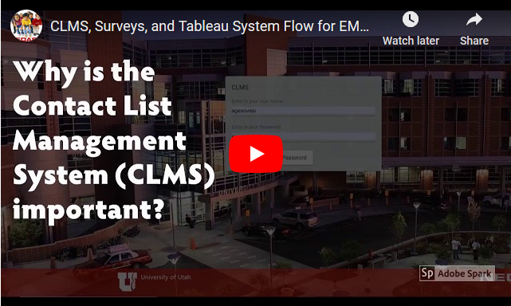

If the video does not play when you click on it, click on this link: https://youtu.be/CJtqoPJsgc8

- EMSC PrograM Manager and EDC tasks for survey deployment

Recommended Tasks for EMSC Program Managers Proven to Increase Response Rates
- Consider other ways to market and promote the survey in your state, such as through your Advisory Board, at state EMS conferences, on social media, and other channels of encouragement.

- Regularly take time to review your response rate in the EMS Response Rate dashboard in Tableau (see “Monitoring Survey Response Rate” below).

More Content Below

OPTION 2: GENERAL TIMELINE TASKS

EMSC Program Manager updates/ verifies state CLMS EMS Agency list and promotes survey
1

EDC opens EMS for Children Survey
2

Day of Launch
EMSC Program Manager emails survey invitation to ALL EMS agencies in CLMS List
@
3

~1 Week After #3
EMSC Program Manager emails 1st Reminder to ALL EMS agencies in CLMS List
@
4

~ 1 Week After #4
EMSC Program Manager emails 2nd Reminder to NON-respondent EMS agencies
@
5

~2 Weeks After #5
EMSC Program Manager emails 3rd Reminder to NON-respondent EMS agencies
@
6

~2 Weeks After #6
EMSC Program Manager emails Final Reminder to NON-respondent EMS agencies
@
7

~1 week after #7 until Survey Close
EMSC Program Manager takes lead on telephone calls to NON-respondents
8

~3 Months After Launch
EDC closes EMS for Children Survey for EMS agencies
9

- additional detail on above timeline
The EDC has developed template language for tasks #3-8 in the timeline on the previous page. These templates will be sent to you so you can familiarize yourself with the language and decide if you wish to make any modifications. If you do modify the language in these email communications, the number of reminders you send, and the timing of when they are sent or phone calls are made, please do so in consultation with your EDC TA liaison. Having this information will help us know what practices are effective in improving survey response.
- Communications for tasks #3 and 4 above are designed to go to all EMS agencies. We recommend that you first download a current list of all EMS agencies from the CLMS Tableau dashboard (direct link provided on the Dashboard page of the CLMS system). Use that list and the email templates that the EDC sends to you to perform a mail merge for these communications. It is important that the contact person for each EMS agency receive an email addressed specifically to them from you to help personalize the invitation. Your EDC TA liaison can assist you in performing a mail merge or you can watch our mail merge tutorial on YouTube.
- For communications relating to tasks #5-7, you should only download a current list of non-respondents from the EMS NON-Respondents dashboard in Tableau. Use that list and the email templates the EDC provides to perform another email mail merge to non-respondents. This again ensures that the contact person for each EMS agency will receive a personalized email addressed specifically to them.
- MONITORING SURVEY RESPONSE rate
Once the survey opens you will be able to review your response/non-response rates thru the EMS Response Rate Report Tableau dashboards at https://tableau.utahdcc.org. These dashboards also show the respondent and non-respondent agencies

These dashboards are updated hourly and we encourage you to view them frequently so you can see changes in your survey response rate at any time during the open survey period. Again, your EDC TA liaison will be happy to assist you in accessing these dashboards.

NOTE: There will be no national survey response rate map.

