Dear [merge respondent’s name]

The [state] EMS for Children Program would like to

THANK YOU!!!

We appreciate you completing the EMS for Children Survey in early 20XX.

The data you provided helps us determine benchmarks in the areas of pediatric emergency care coordination and use of pediatric specific equipment.

Please note that we will be conducting the same brief survey in early 20XX. Please consider participating again when you receive the invitation.

[first name] [last name], [credentials]
[state] EMS for Children Program Manager

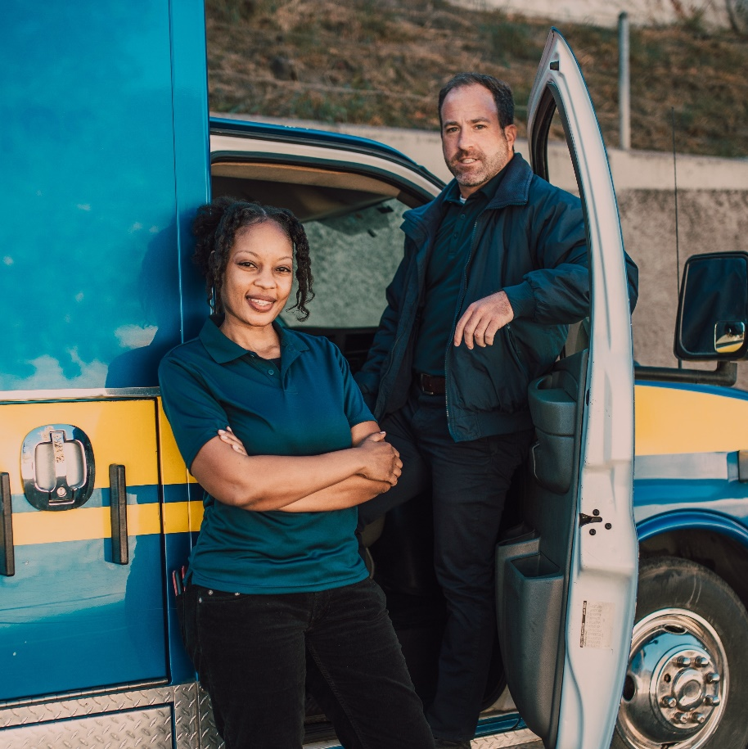
For more information, review the January 2020
Pediatric Readiness in EMS Systems, Policy Statement

[Paste your email signature line here]

